

**Mitsubishi 1 Ton Inverter Series HJ35VA**

**Rs. 81,000/-**

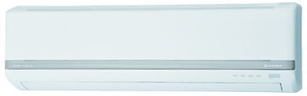

**Product Features**

* Independent Dehumidification
* Low Noise Air Flow System
* Easy Clean Panel
* Remote Control Pocket
* Rust Resistant

**Specification**

**Type** Wall Mounted Split AC

**Cooling (Btu/h)** 48000

**Voltage (V)** 220-240

**Power Input (W)** 5100

**EER (Btu/W-h-W/W)** 9.4-2.75